TEAMS Conversion to Infinite Campus
Effective July 1st, 2023 – the TEAMS system will be retired. Districts will need to enter the data formerly recorded in the TEAMS System into Infinite Campus (Calendar, TOE, Personnel Records, Teacher-Class, CTE, etc.). Policy and program information will be entered in a new application.
Due dates will possibly change (e.g. TOE in December,
Teacher-Class 2x/year – 1st and 2nd Semester)
This document will provide as much information and direction as possible at this point in time for fields required by the reporting changes. Please note this is applicable to all Infinite Campus sites regardless of Edition (State vs. District).
ALL instructions are written to accommodate the New Look of Infinite Campus. Save changes and modifications frequently to prevent losing changes.
Updates to the Previous TEAMS Guide sent in May of 2023 have been denoted with a
Please review all areas with this icon to ensure accuracy as there have been updates and changes to how the data is being pulled from Infinite Campus.
Calendar (Information, Grades, Terms, Days) – The information below should be reviewed for each school calendar and school.
- Select the appropriate calendar for modification. Navigate to Scheduling & Courses > Calendar Setup > Calendar Information.
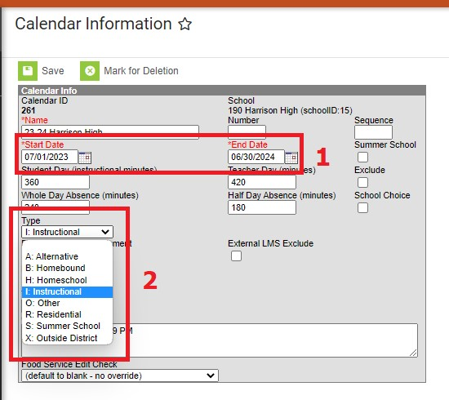
  - Adjust the calendar start and end date fields to reflect the fiscal year (July
1, 20XX to June 30, 20XX).

  - Calendar Type defaults to Instructional – if this is not accurate, another calendar must be created for Alternative and Offsite programs.

- Navigate to Scheduling & Courses > Calendar Setup > Grade Level Setup.
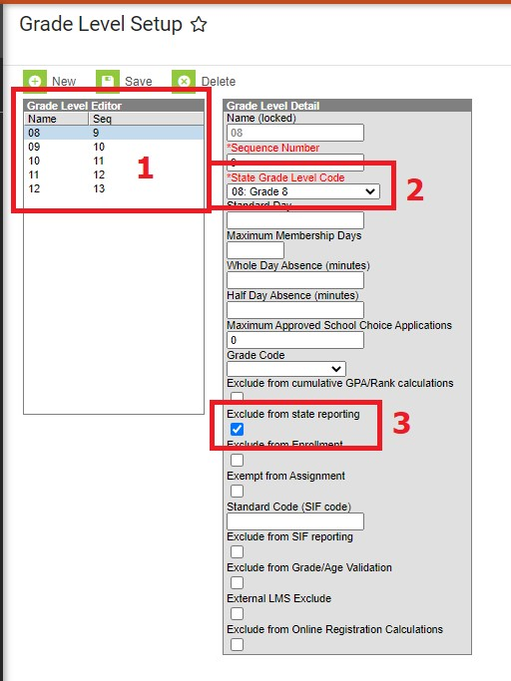
- The grade levels should match grades authorized by the state of Montana; AND served the calendar (e.g. school services grades K-6, but calendar serves grades 5-6).

- Map grades to the state code (e.g., EK/K1 maps to KF, 8th grade maps to 08: Grade 8)

- If grades are served that do not match authorized grade, mark exclude from state reporting (e.g., 8th grade taking HS Algebra).

- Navigate to Scheduling & Courses > Calendar Setup > Term Setup. Review to ensure term dates reflect the actual student start and end dates of school, divided by the appropriate grading periods.
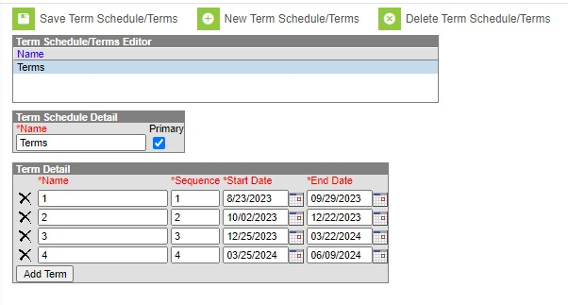
- Navigate to Scheduling & Courses > Calendar Setup > Period Schedule. Review the following examples and replicate appropriately. ***Please note if a new Period Schedule is created, the Copy Section Placement Tool (Scheduling & Courses > Calendar Setup) will need to be used to copy all section placements to the new Period Schedule. ***

- If using an “all day” period schedule (attendance 1x/day), enter all non-instructional time (unstructured recess, lunch) into “lunch time”.
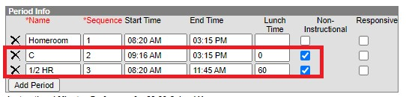
- If using an AM/PM period schedule (attendance 2x/day), enter all non-instructional time (unstructured recess, lunch) into either the lunch time field or a separate line item like Courses below:
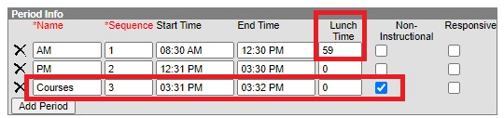
- If using taking attendance by period, enter all non-instructional time (unstructured recess, lunch) into either the lunch time field or a separate line item like TEAM/ACT below:
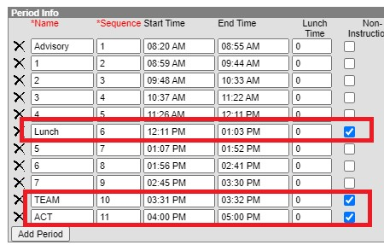
- If using taking attendance in an A/B structure, enter all non-instructional time
(unstructured recess, lunch) into either the lunch time field or a separate line item like ACT below:

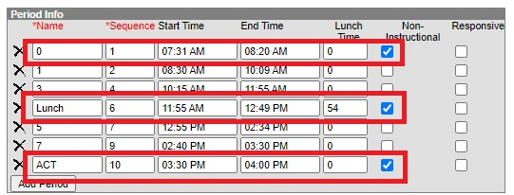

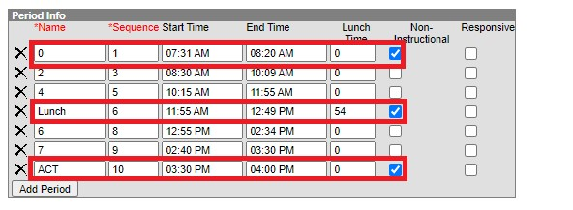
- Navigate to Scheduling & Courses > Calendar Setup > Days. All days including rotations, early release, etc. need to be included in Calendar Setup > Days. PIR and Parent Teacher Conference Days need to be included in each calendar with the appropriate duration. Helpful tips:
- Enter minutes in values of 120 or 360.
- Only use IS (In Service) and PT (Parent Teacher Conference) codes to gain credit with the TEAMS report

See the following examples to adjust days:

In Service Only with No Students in Attendance
  - Select the date when the PIR/In-Service Date is happening by clicking on the Blue number associated with the date: 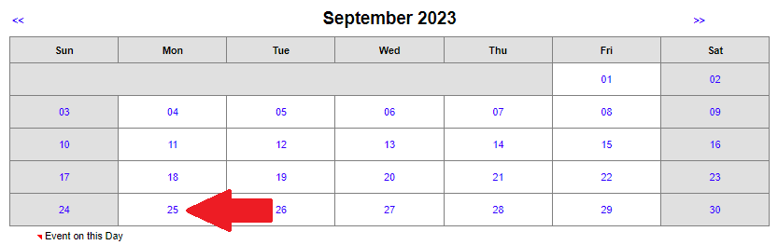
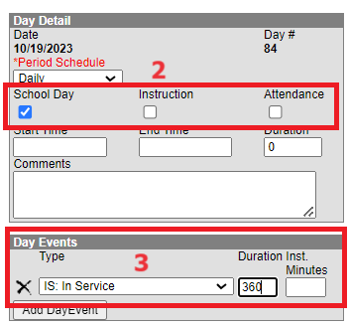
  - Uncheck the boxes for Instruction and Attendance. Leave the School Day checkbox marked.
  - Use the drop down in Day Events to denote the type of day and enter the duration into the duration box ONLY. Do NOT enter anything into the Inst. Minutes box.

In Service Only with Students in Attendance (e.g. half day or after school hours):
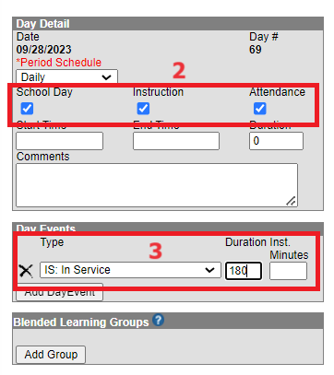
- Select the date when the PIR/In-Service Date is happening by clicking on the Blue number associated with the date.
- Leave all 3 checkboxes marked for School Day, Instruction, and Attendance:
- Use the drop down in Day Events to denote the type of day and enter the duration into the duration box ONLY. Do NOT enter anything into the Inst. Minutes box.

Parent Teacher Conferences with Students in Attendance (e.g. half day or after school hours):
- Select the date when the Parent Teacher Conference is happening by clicking on the Blue number associated with the date.
- Leave all 3 checkboxes marked for School Day, Instruction, and Attendance:
- Use the drop down in Day Events to denote the type of day and enter the duration into the duration box ONLY. Do NOT enter anything into the Inst. Minutes box.

Courses – Each school needs to review ALL courses to ensure accuracy for the fields highlighted below. Once completed, this will roll each year when calendars are rolled and
should not have to change unless there are course changes within the school.
Resource for ALL SCED Codes – ANY course with a different teacher than the homeroom teacher MUST have an NCES/SCED code.
https://opi.mt.gov/Portals/182/Page%20Files/School%20Accreditation/Standards%20of%20Accreditation/App endix%20Files/B/Course%20Codes%202022-2023.pdf?ver=2022-09-07-154450-633
For ALL K-12 Courses:
  - Navigate to Scheduling & Courses > Course Information > Search
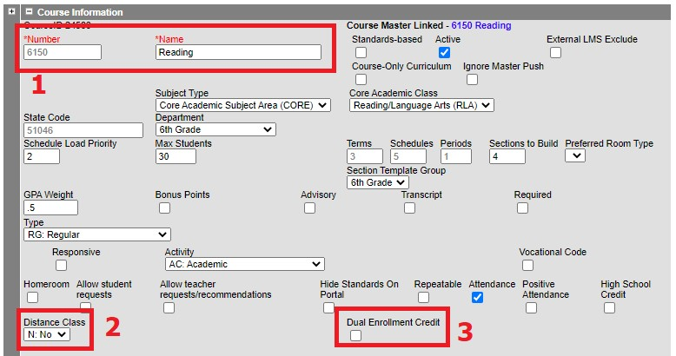
        - Course number and name fields are required; however, there are no formatting requirements.
        - Districts offering distance classes – defined as classes offered remotely (not offsite) – use drop down to denote if Yes.
        - Dual Enrollment Credit courses where students earn both High School and College credit must check this box.
  - For Elementary Courses: All homeroom or attendance taking courses need to have SCED information input. Those courses where there is a teacher change will also need to have SCED information entered. Please see examples below.
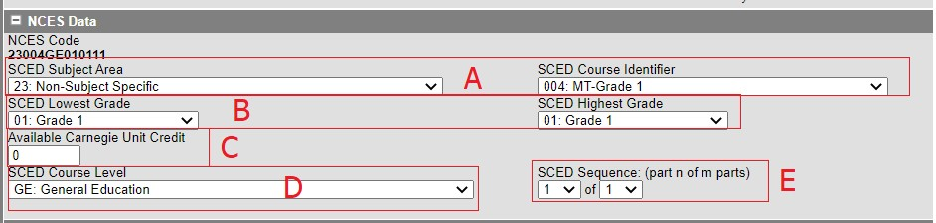
- Select the appropriate SCED Subject Area first then the appropriate SCED Course Identifier.
  - SCED Subject Area – first 2 digits of the NCES Course Identifier
    - ALL Homeroom or Attendance taking courses should start with 23: Non-Subject Specific
    - Subject areas where the teacher is NOT different from the homeroom do NOT need a SCED code.
    - Subject areas where there is a formal teacher change (e.g. Music, P.E., etc.) should be denoted with a SCED Subject area over 50 and includes the verbiage
(prior-to-secondary)
  - SCED Course Identifier – last 3 digits of the NCES Course Identifier (Must be a code prefaced by MT)
- SCED Lowest and Highest levels for Elementary are set to reflect the lowest grade the course is designed for to the highest grade the course is designed for.
- Available Carnegie Unit Credit should be set to match the credit received for the course.
  - If the course does not receive credit (as is common with Elementary courses), the Carnegie Unit Credit would be 0.
- SCED Course level should be set to reflect the courses intended audience. Most courses will be denoted as GE: General Education; however, SE: Special Education and HO: Honors are available.
- SCED Sequence should be set to 1 of 1; unless class is progressive.
- Once these fields have been set, notice the NCES Code updates.
- Repeat process accordingly.
- Example of Non-SCED reporting course:
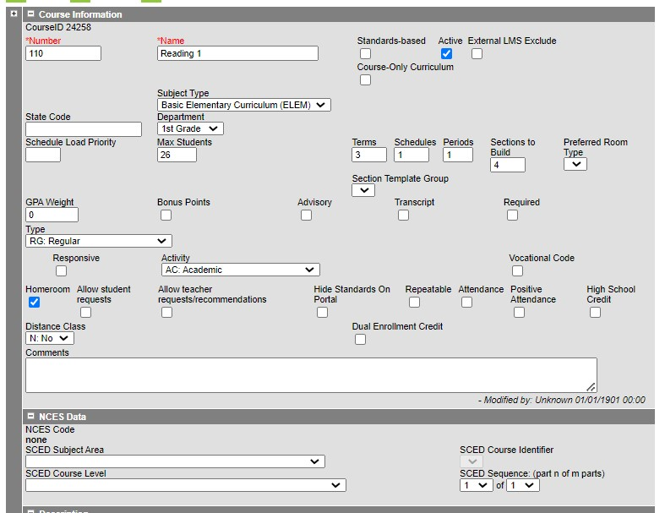
- Example of change in Teacher course:
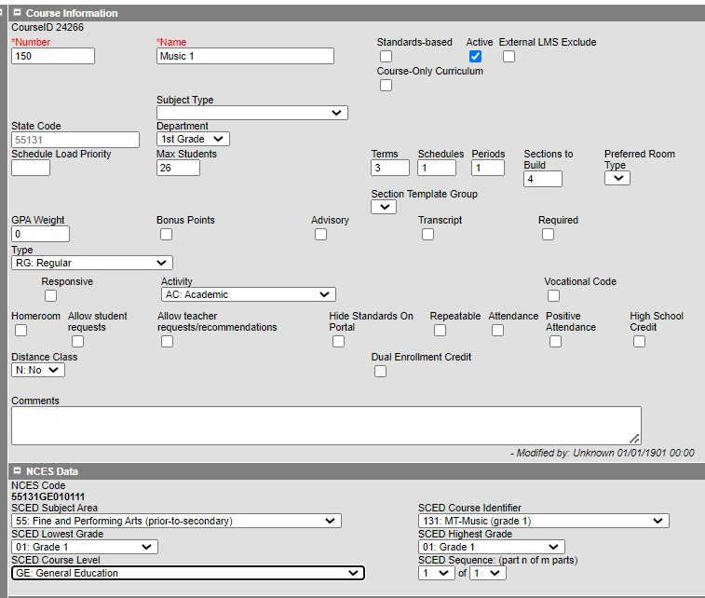
- For Middle School or JHS: Depending on District/School size, either the Elementary Instructions or the HS Instructions for SCED reporting can be taken.
  - If students change teachers each period, follow the HS instructions.
  - If the students stay with the same teacher, follow the Elementary instructions.
- For High School (Grades 9-12): All High School Courses MUST be marked with SCED information.
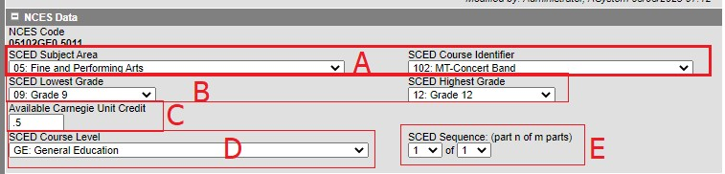
A. Select the appropriate SCED Subject Area first then the appropriate SCED Course Identifier.
      - SCED Subject Area – first 2 digits of the NCES Course Identifier
      - SCED Course Identifier – last 3 digits of the NCES Course Identifier (Must be a code prefaced by MT)
    - SCED Lowest and Highest levels for high school are set to reflect the lowest grade the course is designed for to the highest grade the course is designed for.
    - Available Carnegie Unit Credit should be set to match the credit received for the course.
        - To determine the credit, multiple the credit received by each term by the number of terms the credit is given.
          - Full Year Course with Semester Grading Task earning 0.5 credits 2 times/ year = 1 Carnegie Unit Credit
          - Semester Course with Semester Grading Task earning 0.5 credit 1 time/ year = 0.5 Carnegie Unit Credits
          - Quarter Course with Quarter Grading Task earning 0.25 credits 2/ year = 0.5 Carnegie Unit Credits
    - SCED Course level should be set to reflect the courses intended audience. Most courses will be denoted as GE: General Education; however, SE: Special Education and HO: Honors are available. E. SCED Sequence should be set to 1 of 1; unless class is progressive.
    - Once these fields have been set, notice the NCES Code updates.
    - Repeat process for each course.
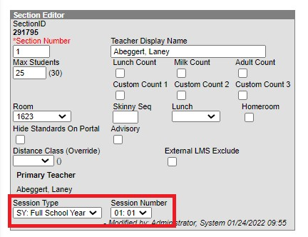
Sections (Session Type, Session Number,
Staff History) – Each school needs to review ALL sections to ensure accuracy for the fields highlighted below. Once completed, this will
roll each year when calendars are rolled and should not have to change unless there are section placement changes within the school.
  - Navigate to Scheduling & Courses > Search > Courses > Locate Course and select Section Information.
  - For ALL schools/all grades/all sections, each section needs to denote Session Type and Session Number:

      - Session Types: This field denotes the length of the course. The most commonly used types are FY (Full Year), Semester (SM), Quarter (QT), and Trimester (TM).
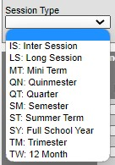
      - Session Numbers: This field determines when the course takes place and is dependent on the Session Type chosen. C. Examples:
          - Semester 2 Course - Session Type: SM, Session Number: 02
          - Quarter 3 Course - Session Type: QT, Session Number: 03 iii. Trimester 1 Course - Session Type: TM, Session Number: 01 iv. Full Year Course – Session Type: FY, Session Number: 01
  - Staff History – Based on whether the section belongs to a state reported course (one with a SCED code) determines what the role of the Staff Member is to the Course.
  - 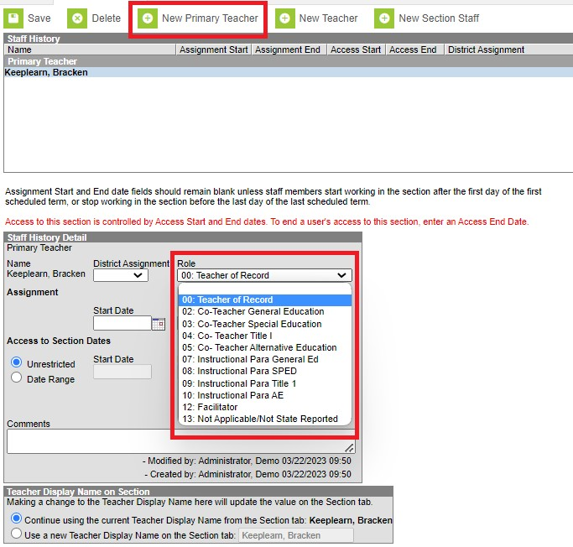
      - Click New Primary Teacher
      - Select Teacher from List.
      - Determine Role based on if the course is state reported (SCED code):
          - Teacher of Record – all courses that are state reported
          - Not Applicable/Not State Reported – courses not state reported (e.g. Elementary reading, math, etc.)
D. Do not enter State Date or End Dates unless there is a staff change.

Additional Resources:
  - TEAMS: https://opi.mt.gov/Leadership/Assessment-Accountability/SchoolAccreditation/TEAMS#9749310915-opi-teams-resources
  - License/Certification Lookup:
https://ebizws.mt.gov/PUBLICPORTAL/searchform?mylist=licenses
https://teachmontana.com/Account/Login?ReturnUrl=%2F
  - AIM Help Desk: 406.444.3800 or 877.424.6681 https://opiservicedesk.opi.mt.gov/help/servicedesk/customer/portal/7/user/login?nosaml&desti nation=portal/7
  - School Services of MT: support@mt-schools.org
  - Campus Community: https://community.infinitecampus.com

